**Network Fundamentals Lecture 11 Notes**

**Characteristics of Value-Added WAN’s**

* Unlimited distance
* - Interconnection is by means of public carriers
* Only the interface and network services are of concern to the user
* - The internals of the “network cloud” are not an issue
* Usually lower data rate and higher cost than LAN’s
* - But some evolving WAN services have comparable data rates with those of LAN’s
* Value-added WAN’s add features beyond those of dedicated, point-to-point links
* Transparent LAN services (TLS) hide the complexities of the WAN from the LAN administrator

**Switched Public Network Options**

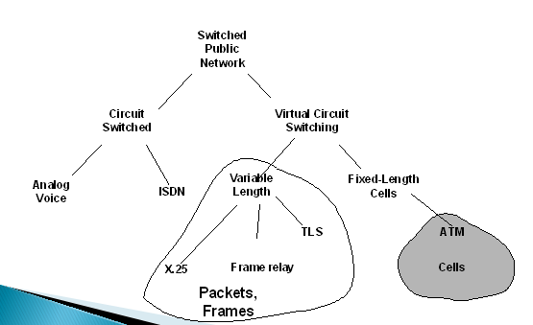

**Packet/Frame/Cell-Switched WAN Links**

* Individual data units may be called
* - Packets
* - Frames
* - Cells
* The principal distinction is that packets and frames are of variable length
* - They usually require software processing
* - This limits the data processing rate (X.25, frame relay and TLS are examples)
* In contrast, cells are fixed length
* - A 5-byte header and a 48-byte data content
* - They can be processed in hardware
* - This results in much higher data rates (ATM is an example)

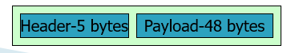

**Switched and Permanent Virtual Circuits**

* Some packet/frame/cell WAN alternatives may be available in one or each of two forms
* - Switched virtual circuits – SVC
* - Permanent virtual circuits – PVC
* Switched circuits are like dial-up links
* Permanent circuits are always connected
* - Dedicated circuit
* Not all WAN technologies support both
* - Some have a preferred approach in terms of usage
* - - X.25 VCs are usually SVCs
* - - Frame-relay VCs are normally PVCs
* - - ATM VCs may be either PVCs or SVCs
* - TLS is more like a “best efforts” services

**Objectives and Services for Value-Added WANs**

* To provide an appropriate topology

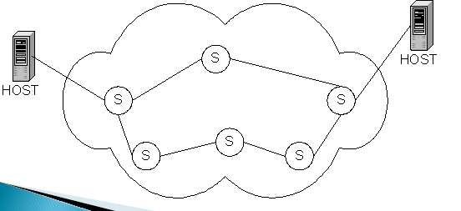

* To provide a path (route) across the network

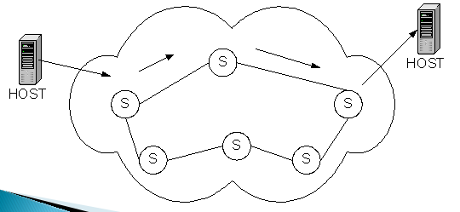

* To divide (segment data as required and to reassemble the segment)

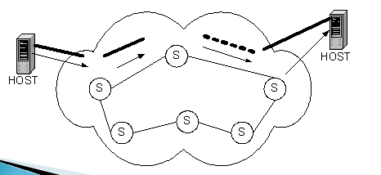

* To limit the network traffic to that which can be handled effectively (congestion control)

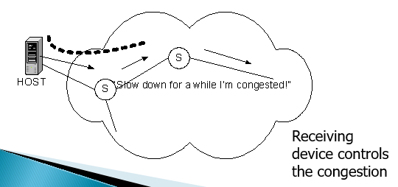

**X.25 Interface**

* X.25 is a WAN interface standard
* - To connect to a public packet-switching network
* - With physical, data link and network layer standards
* - May be used with a variety of network-attached devices

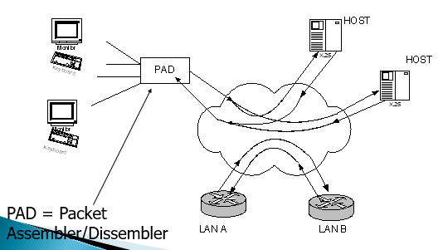

* X.25 is the legacy packet-switching WAN
* - Ubiquitous availability worldwide
* Originally intended for terminal-to-host connectivity
* X.25 provides reliable transfer
* Marginally adequate for LAN-to-LAN connectivity
* - Typically, X.25 bandwidth is about 64kbit/s

**Summary**

* WAN Links are usually
* - Provided by public carriers
* - Lower data and higher cost than LANs
* X.25 Networks also include a network layer Protocol
* - Frame relay offers an alternative to X.25
* - Frame relay operates at the data link layer
* WAN links are becoming available with higher data rate]
* - Frame relay
* - ATM
* Key network concepts
* - Virtual Circuits (SVC and PVC)
* - Packet, frame and cell-switching concepts
* - ATM as an alternative networking approach (ATM adaptation for voice, video, data etc and ATM segmentation (into cells) and reassembly)
* - Transparent LAN service